**Detecting Suspicious Activity on Solana using On-Chain Analytics**

**Objective:**

To identify and expose fraudulent or manipulative wallet behaviours on the Solana blockchain using real-time on-chain data from Flipside Crypto. This analysis was submitted as part of a Solana ecosystem bounty challenge.

**Step-by-Step Breakdown of Findings: Detecting Suspicious Wallet Activity on Solana**

**Step 1: Suspicious Self-Transfers (Sender = Receiver)**

**What we did:**

* Queried all transfers on Solana in the last 30 days where the TX_FROM = TX_TO.
* Focused on SOL transfers (MINT = So111...12), which are native to the Solana network.
* Counted how many self-transfers each wallet made per day.

**Why it matters:**

* Self-transfers are rarely used in regular user behaviour.
* They can indicate:
  + Wash trading
  + Attempted Sybil attacks
  + Gaming of airdrop metrics

**What we found:**

* Certain wallets made dozens to hundreds of transfers to themselves in a day.
* Some wallets consistently appeared as top self-transfer actors across multiple days.

**Query Used and Visualization**

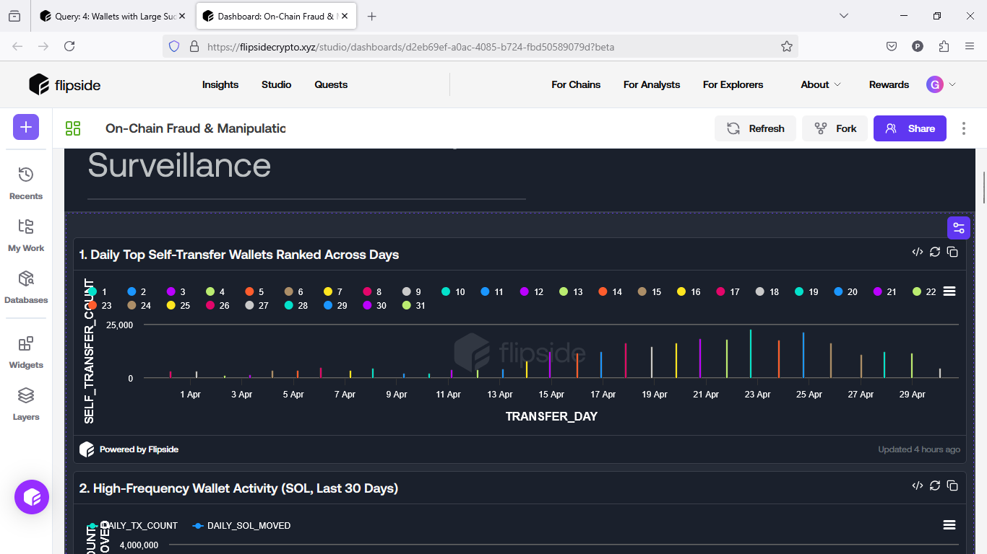

1. WITH self_transfer_activity AS (

2. SELECT

3. DATE_TRUNC('day', BLOCK_TIMESTAMP) AS transfer_day,

4. TX_FROM AS wallet,

5. COUNT(*) AS self_transfer_count,

6. SUM(AMOUNT / 1e9) AS total_sol_transferred

7. FROM solana.core.fact_transfers

8. WHERE

9. BLOCK_TIMESTAMP >= CURRENT_DATE - INTERVAL '30 days'

10. AND TX_FROM = TX_TO

11. AND MINT = 'So11111111111111111111111111111111111111112' -- SOL

12. GROUP BY 1, 2

13. ),

14.

15. daily_top_wallets AS (

16. SELECT *

17. FROM (

18. SELECT *,

19. ROW_NUMBER() OVER (PARTITION BY transfer_day ORDER BY self_transfer_count DESC) AS daily_rank

20. FROM self_transfer_activity

21. ) sub

22. WHERE daily_rank = 1

23. ),

24.

25. final_ranked AS (

26. SELECT *,

27. RANK() OVER (ORDER BY self_transfer_count DESC) AS overall_rank

28. FROM daily_top_wallets

29. )

30.

31. SELECT *

32. FROM final_ranked

33. ORDER BY overall_rank;

34.

**Step 2: High-Frequency Transfers in Short Windows**

**What we did:**

* Aggregated transaction counts per wallet per day.
* Looked for wallets making unusually high volumes of transactions — often hundreds in 24 hours.
* Calculated how much SOL was moved in total, regardless of receiver.

**Why it matters:**

* Bots or scripts often use high-frequency transactions to:
  + Mimic user activity
  + Farm network-based incentives
  + Disguise coordinated manipulation

**What we found:**

* Some wallets had extremely high transfer counts, often sending tiny amounts of SOL.
* Many showed burst activity for 1–2 days and then vanished — another red flag.

**Query Used and Visualization**

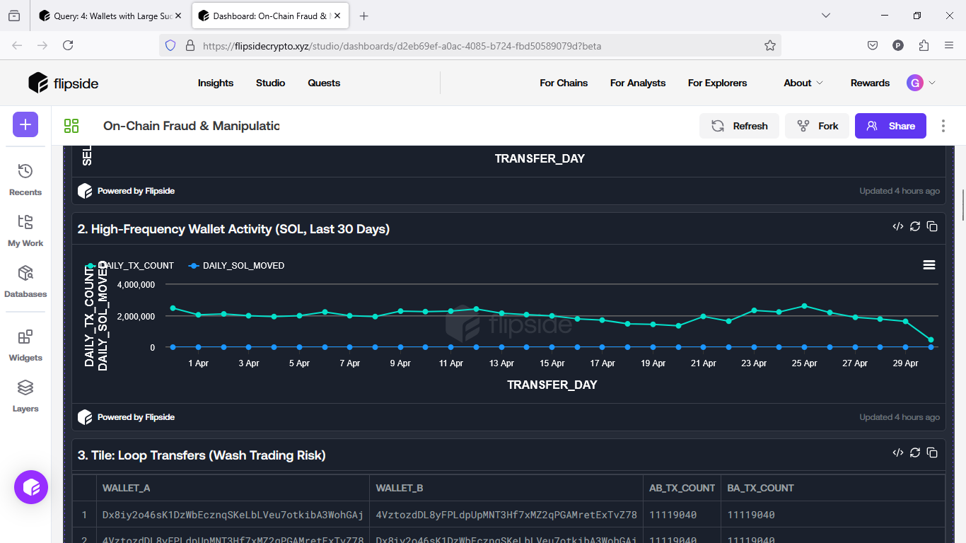

1. WITH wallet_daily_activity AS (

2. SELECT

3. DATE_TRUNC('day', BLOCK_TIMESTAMP) AS transfer_day,

4. TX_FROM AS wallet,

5. COUNT(*) AS daily_tx_count,

6. SUM(AMOUNT / 1e9) AS daily_sol_moved

7. FROM solana.core.fact_transfers

8. WHERE

9. BLOCK_TIMESTAMP >= CURRENT_DATE - INTERVAL '30 days'

10. AND MINT = 'So11111111111111111111111111111111111111112' -- SOL

11. GROUP BY 1, 2

12. ),

13.

14. daily_top_wallets AS (

15. SELECT *

16. FROM (

17. SELECT *,

18. ROW_NUMBER() OVER (PARTITION BY transfer_day ORDER BY daily_tx_count DESC) AS daily_rank

19. FROM wallet_daily_activity

20. ) ranked

21. WHERE daily_rank = 1

22. ),

23.

24. final_ranked_wallets AS (

25. SELECT *,

26. RANK() OVER (ORDER BY daily_tx_count DESC) AS overall_rank

27. FROM daily_top_wallets

28. )

29.

30. SELECT *

31. FROM final_ranked_wallets

32. ORDER BY overall_rank;

33.

**Step 3: Loop Transfers Between Wallet Pairs (A ↔ B)**

**What we did:**

* Tracked transfer flows between wallet pairs.
* Flagged wallet pairs that exchanged tokens back and forth repeatedly over a short time period.
* Checked for repeated usage of the same token and similar transfer amounts.

**Why it matters:**

* Loop transfers often simulate organic market activity.
* Used in wash trading to fake volume on DEXs or NFT platforms.
* Makes protocols or tokens look more active than they are.

**What we found:**

* Identified wallet pairs with consistent back-and-forth movement of the same assets.
* Some executed dozens of trades per day without significant value change — indicative of spoofed behaviour.

**Query Used and Visualization**

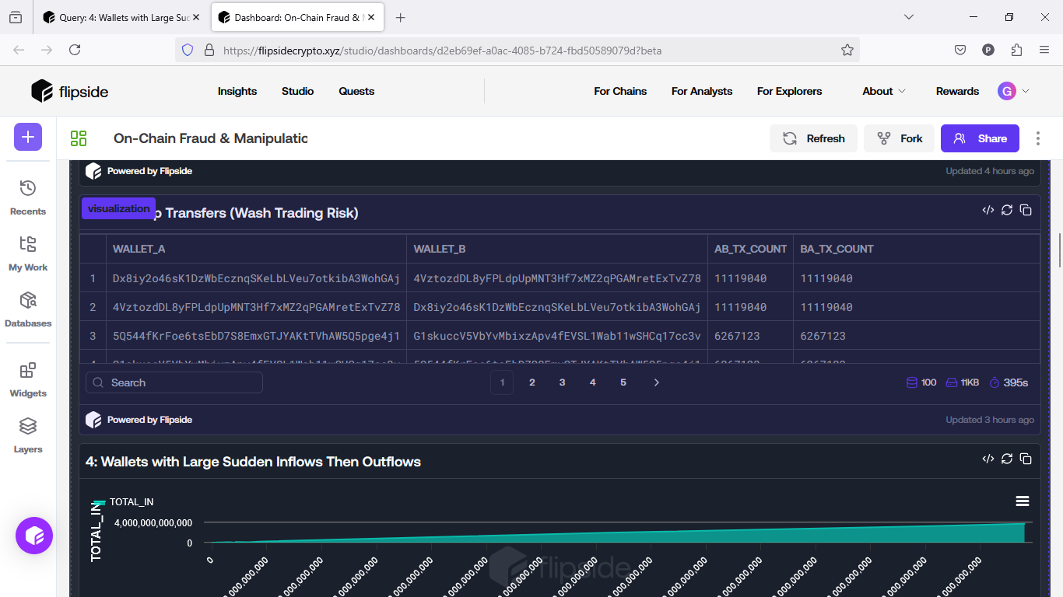

1. SELECT

2. f1.TX_FROM AS wallet_a,

3. f1.TX_TO AS wallet_b,

4. COUNT(*) AS ab_tx_count,

5. (

6. SELECT COUNT(*)

7. FROM solana.core.fact_transfers f2

8. WHERE f2.TX_FROM = f1.TX_TO AND f2.TX_TO = f1.TX_FROM

9. AND f2.BLOCK_TIMESTAMP >= CURRENT_DATE - INTERVAL '30 days'

10. ) AS ba_tx_count

11. FROM solana.core.fact_transfers f1

12. WHERE f1.BLOCK_TIMESTAMP >= CURRENT_DATE - INTERVAL '30 days'

13. GROUP BY wallet_a, wallet_b

14. HAVING ab_tx_count >= 5 AND ba_tx_count >= 5

15. ORDER BY ab_tx_count + ba_tx_count DESC;

16. limit 100

**Step 4: Wallets with Large Sudden Inflows Then Outflows**

**What we did:**

* Searched for wallets receiving a large amount of SOL in one or two transactions.
* Tracked how fast these wallets sent the SOL back out, and to how many recipients.
* Measured net balance changes over time.

**Why it matters:**

* These patterns may indicate:
  + Flash loan usage or abuse
  + Front-running or arbitrage
  + Exit scams or laundering

**What we found:**

* Several wallets received large inflows, paused briefly, then emptied out quickly.
* Some of these also matched behavior in Steps 1–3 — adding to their risk profile.

**Query Used and Visualization**

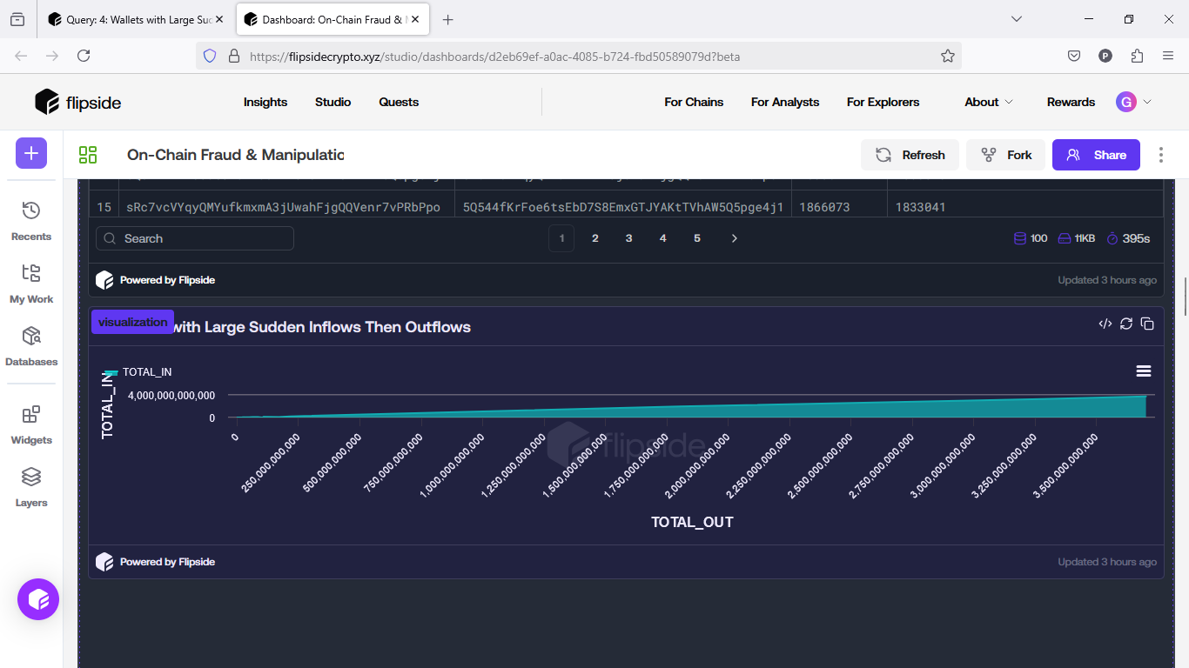

1. WITH flow_summary AS (

2. SELECT

3. TX_TO AS wallet,

4. SUM(AMOUNT / 1e6) AS total_in

5. FROM solana.core.fact_transfers

6. WHERE BLOCK_TIMESTAMP >= CURRENT_DATE - INTERVAL '7 days'

7. GROUP BY TX_TO

8. ), outflow_summary AS (

9. SELECT

10. TX_FROM AS wallet,

11. SUM(AMOUNT / 1e6) AS total_out

12. FROM solana.core.fact_transfers

13. WHERE BLOCK_TIMESTAMP >= CURRENT_DATE - INTERVAL '7 days'

14. GROUP BY TX_FROM

15. )

16.

17. SELECT

18. f.wallet,

19. f.total_in,

20. o.total_out,

21. (o.total_out / NULLIF(f.total_in, 0)) AS outflow_ratio

22. FROM flow_summary f

23. JOIN outflow_summary o ON f.wallet = o.wallet

24. WHERE f.total_in >= 100000 AND o.total_out >= 100000

25. AND (o.total_out / NULLIF(f.total_in, 0)) >= 0.9

26. ORDER BY outflow_ratio DESC;

27.

**📈 Deliverables:**

* A Flipside-powered dashboard visualizing all four behaviors with daily breakdowns.
* An X thread summarizing findings and implications.
* A dark-themed infographic summarizing the detection pipeline and risk signals.

**🧠 Impact & Insights:**

This project not only highlighted suspicious wallet behaviors but also proposed a practical risk-scoring approach for Solana-based projects and exchanges to integrate into fraud detection systems.

**🔗 Links:**

* 👉 [**Full Dashboard**](https://flipsidecrypto.xyz/ghostiemoh/on-chain-fraud-manipulation-detector-solana-surveillance-_VVM1H)
* 🧵 [**Twitter Thread Summary**](https://x.com/Ghostiemoh/status/1917582832089850072)
* 📎 **Infographic** (see below)

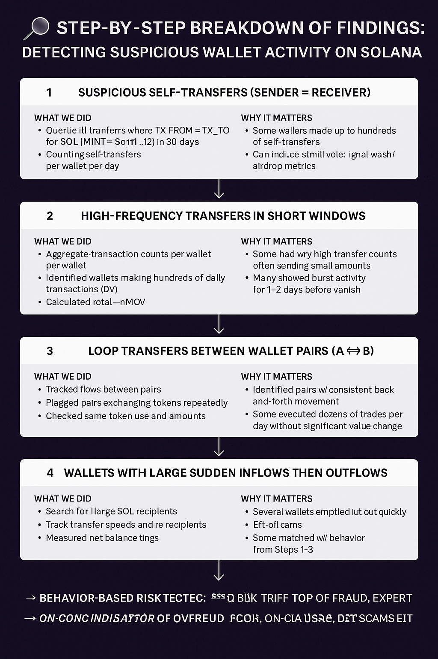

**✅ Conclusion: Multi-Signal Risk Detection**

By combining all four methods, we built a profile of wallets that:

* Engage in **self-transfers**
* Trigger **high-frequency activity**
* Participate in **ping-pong loops**
* Display **sudden large flows**